University of Bristol PGR Training Review: Report to the Steering Group
Authors: Maxine Sims (PGR Development Officer, Paul Spencer (PGR Environment Development Manager and Sarah Watts (PGR Development Adviser)
Date of report: May 2023
Contents
Executive summary 1
Summary of recommendations 2
Introduction 2
Summary of findings from the stakeholder discussions (PGRs) 3
Summary of findings from the stakeholder discussions (staff) 5
Other issues raised in the review 6
Appendices 8

Executive summary
This review and its recommendations are presented as outputs from the task group established following the October meeting of the University Postgraduate Research Committee (UPGRC). The aims of this review were to establish a holistic view of training and development opportunities across many different providers and stakeholders to identify any significant gaps and/or duplication in provision, to map (at a meta level) how the provision intersects with the Vitae Researcher Development Framework (RDF) and to highlight where the visibility of the provision could be enhanced. The work was carried out by colleagues in the Bristol Doctoral College with the project being overseen by a Steering Group to provide guidance and expertise.
The main findings from this review were:
- PGRs identified that there should more guidance on what, why and how to develop themselves in the RDF Domain C (Research Governance and Organisation) along with confidence building and opportunity to practice elements of domain D (communication, presenting, writing, engagement)
- Increased help and guidance for PGRs is needed in navigating and accessing appropriate training at the right time
- Strong appetite for more creative development opportunities through peer-learning, professional and interdisciplinary networks
- The current training and development offer maps across multiple domains of the RDF with a bias to one or two. In schools and faculties this is concentrated on themes in Domain A (Knowledge and intellectual abilities) and professional services concentrating their offer in Domain D (Engagement, influence and impact). The exception are the DTEs, who create development programs spanning all domains of RDF, and the library teams who support researchers in different ways with most aspects of research
- Visibility of a comprehensive training and development offer is challenging because of the quantity of opportunities available from different parts of the University which requires the improvement of the coherence and navigation of the training offer to make it easier for PGRs to engage and for staff to support that engagement

Summary of recommendations
The Steering Group proposed recommendations that cover three main areas; 1) empowering PGRs to own their development, 2) improving navigation of the training offer (both staff and students) and 3) development of an essential training programme. It is recognised that some of these recommendations will need additional resource and will be scoped as part of the implementation.
Recommendation 1. To address the identified gaps in provision in Domain C of the RDF (Research Governance and organisation), generic training content on the professional conduct in research (i.e. research integrity, ethics, research funding) to be commissioned and developed as soon as possible. Reframe the University’s training and development offer in terms of the behaviours and expectations of PGRs to drive their own development to empower them with the skills and knowledge to make choices about what development they need to access and when.

Recommendation 2. The Bristol Doctoral College should curate a core set of essential training and development to introduce PGRs to professional research conduct including establishing effective working relationships with supervisors, collaboration with non-academic partners etc.

Recommendation 3. To empower PGRs to drive their own development, expectations and behaviours about skills development. This should be set out from induction (at all levels) so that PGRs have the agency to make informed choices about what development they need to access and when.

Recommendation 4. Improved navigation of the training and development offer for both postgraduate researchers and the staff that support them, including better curation (both at a faculty/school level and university-wide) for subsets of the PGR community.

Recommendation 5. Faculties, schools or research groups (whichever is appropriate in critical mass) to provide more opportunities for their PGRs to practice their skills (e.g. in presentation of research, critical reading, teaching etc) by the facilitation of peer–to-peer learning communities.

Recommendation 6. Build upon the success and demand of writing support opportunities available, including targeted support in partnership with the Centre for Academic Language Development.

Recommendation 7. To increase PGR access to other training and development opportunities by opening up more of the opportunities offered to staff.

Recommendation 8. Establish the Steering Group as an oversight mechanism for the quality of the University training and development offer as a regular review (annually) and as a focal point for sharing of practice among stakeholders.

At its May meeting, UPGRC approved these recommendations that the Steering Group put forward subject to securing the financial resources, where necessary, to implement as part of both the PGR Strategic Implementation and the Student Experience Programme.

Introduction
The University is committed to providing personal and professional development opportunities for its research students to complement and build on the research and other skills gained through pursuing their research. It’s incumbent on the University that appropriate support and development be available to our postgraduate research (PGR) community to help them to succeed regardless of their career path. Over the past decade, the Bristol Doctoral College have coordinated access to a broad range of training and development opportunities through its Personal and Professional Development programme designed to complement the provision of training and support through faculties, schools and doctoral training entities (DTEs). In October 2022, the University Postgraduate Research Committee (UPGRC) approved a proposal to establish a Task Group to conduct a review of the provision of research skills training across the University.
The two main drivers for this review are;
- the stated objective in the strategic plan for postgraduate research to provide exceptional training, development, and support to our PGRs
- responding to feedback from previous Postgraduate Research Experience Surveys (PRES) with respect to research skills development that indicate the low awareness of the full range of opportunities available to the PGR community.
The aims of this review were to establish a holistic view of training and development opportunities across many different providers and stakeholders to identify any significant gaps and/or duplication in provision, to map (at a meta level) how the provision intersects with the Vitae Researcher Development Framework and to highlight where the visibility of the provision could be enhanced.
The review was undertaken by Bristol Doctoral College staff through a series of structured discussions (see appendix 1) with different stakeholders and a focus group of PGRs, collating feedback about the training and development offer.
A steering group, chaired by the Academic Director of Doctoral Training Entities and drawing on representatives of UPGRC and representatives from schools, was established to ensure effective oversight, provide expertise and feedback on the review.

Summary of findings from the stakeholder discussions (PGRs)
The focus group with PGRs explored three key areas; identifying their skills development needs with respect to the RDF, highlighting strengths and gaps in current provision (again with reference to the RDF) and the generation of ideas for enhancement to an ideal research training offer. The key themes that emerged are highlighted below.
- Identifying the development needs of PGRs using guidance from the RDF (what do PGRs think is most needed)
PGRs ranked their confidence experience with the skills, knowledge and attributes located in domains B (Personal effectiveness) and Domain A (Knowledge and intellectual abilities) although confidence in the sub-domain B3 (Career management) was lower than the other sub-domains in B.
Domains C and D were the areas that PGRs felt least confident, the skills required in professional conduct (C1) and skills relating to finance and funding (C3) were of highest need. They felt more confident in sub-domain D1 (working with others) than in D1 (Communication and dissemination) and D3 (Engagement and impact) including Teaching and Public Engagement.
- Identifying strengths and gaps in university support using guidance from the RDF
PGRs (both in the focus group and discussion with the PGR representatives) were generally positive about the quality of research skills development opportunities available across the University. The following were highlighted as strengths in the focus group.
Table 1. Strengths highlighted by the PGR focus group
Wellbeing | Online provision, being able to access things online, this is easier and cost effective.
Research methods | Centre for Academic Language Development – in particular the Research, English and Academic Literacy (REAL) programme
Supervision | Faculty specific training (e.g. EngF)
library support for research | Compulsory personal effectiveness training offered by CDT
extra-curricular community building opportunities | Writer’s Retreats
transferable skills training e.g planning and managing your time, wellbeing (offered from lots of different areas) | Workshops for each stage of the degree (BDC Lifecycle sessions)

Areas considered as gaps were also considered by the PGRs, the majority of the examples in Domains C and D which mirrors what their perceived needs already identified. Examples given are shown below in Table 2.
Table 2. Perceived gaps in provision highlighted by the PGR focus group
Access to funding support for research projects – field work and travel | Academic career support
Funding – how to write a proposal, find and secure opportunities | Part-time work for PGRs that also work for internationals on visa restrictions and are relevant to their research
Peer based academic support | Supervision – standards are variable and supervisors are not always good mentors
Professional networks (more important than social networks) there are opportunities for these to be themed by broad topic e.g research method, or environment | Discipline specific publishing
Awareness of opportunities – information is not well curated or easy to find and there is inequity of opportunity. There is a problem navigating the support | Foreign language training
Processes and tools support around data analysis and software packages | Responsible research training – the level that PGRs should be at should be established and built upon
Ethics – this can be offered at a broad introductory level and then followed up with more details at school level due to disciplinary differences | Conference presenting at a faculty level

- Design what you think a successful PGR Training offer looks like (areas for enhancement)
Focus group participants were asked to generate some ideas for a successful PGR training offer using the Dreamer, Realist, Critic strategy. The summary of those ideas related to,
- More practical guidance on what, why and how to for domain C
- Confidence building and opportunity to practice in domain D (communication, presenting, writing, engagement).
- More help and guidance navigating and accessing training at the right time.
- Standardization where it can be applied across supervision and schools to reduce inequity of experience.
- Strong appetite for more creative development opportunities through peer-learning, professional and interdisciplinary networks.

Summary of findings from the stakeholder discussions (staff)
Engagement with a diverse range of stakeholders highlighted some important themes during this review and are summarised here.
- Terminology. Most stakeholders agreed the term training was quite narrow and would use development in preference as it reflects both the variety of their offer and the breadth of ways that individuals can learn. Where the term training is used, it is usually to reference a synchronous course or workshop for the acquisition of a particular skill.
- Quantity and quality of training, development and support. There are a variety of modes of engagement and support offered including courses and workshops delivered both face to face and online, online information and resources and, in some cases, 1:1 support options. A significant proportion of these opportunities are front loaded toward the early stages of a research degree. Community and peer-led learning avenues were well received by PGRs where they existed.
- Current strengths/provision in high demand. Cited as the most popular was writing support, particularly in the form of retreats with peers and considered high value. The provision of specific training in software and data analysis was also an area of demand.
- Gaps in provision. A common theme identified by stakeholders was variable support for specific practical skills and understanding of the academic research environment in terms of navigating processes and procedures necessary to transition toward being an independent researcher. The awareness of the value of the skillset in a broader context outside of the academic research environment was identified as being a deficit area. The most often cited areas was the level of support for doctoral level writing, interdisciplinary working, and collaboration. Staff who support PGRs reported that a lack of independence, self-awareness and low resilience acted as a barrier to access the right support proactively, a sense that training and development needed to be curated for some groups.
- Mapping against the Researcher Development Framework (RDF). In terms of a meta level analysis, most stakeholders offer training and development across multiple domains of the RDF with a bias to one or two. As expected, much of the support offered by schools and faculties concentrated on themes in Domain A (Knowledge and intellectual abilities) and professional services concentrating their offer in Doman D (Engagement, influence and impact). The exception are the DTEs, who create development programs spanning all domains of RDF, and the library teams who support researchers in different ways with most aspects of research.

Figure 1. Meta level mapping of research skills development to the Researcher Development Framework (RDF)
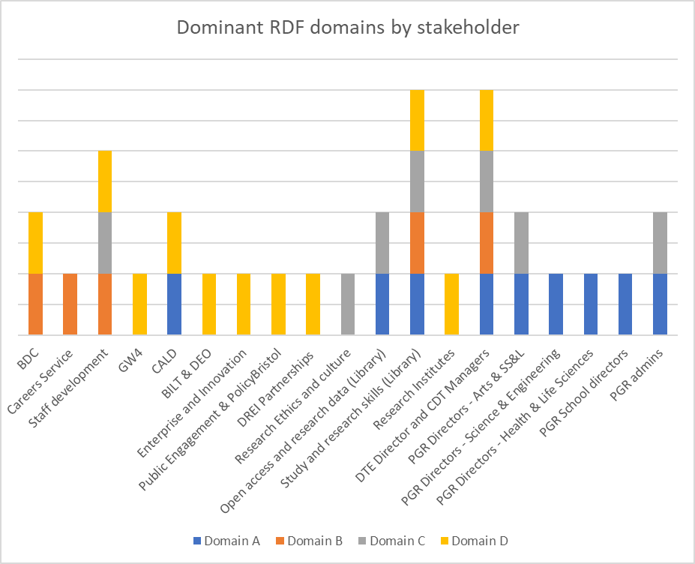

Other issues raised in the review
Training that is inclusive of a diverse range of needs was a constant theme in the structured discussions. The needs of international PGRs were mentioned in relation to language and cultural background presenting challenges in academic writing at doctoral level. Other groups of PGRs were discussed including those with caring responsibilities, neurodiverse, mature and/or returning students, those studying from a distance and those from low socio-economic backgrounds.
The offer of different modes of engagement, different times for in person events, online delivery, hybrid/blended delivery, asynchronous resources has greatly improved since the onset of the pandemic but acknowledged that not all stakeholders have progressed at the same rate.
Access to training and development offered to staff was another area explored in the discussions. Most services and departments are structured to support either students or staff but there were some notable examples where the provision of support to a mixed audience of researcher experience was seen as beneficial e.g. open research and using digital tools to promote your research reputation as these are often new to all. The flip side is that there are some topics where PGR cohorts should discuss PGR issues in a safe space e.g. how to get the best from your supervisor.
The role of the supervision team in supporting PGRs to access and engage in development opportunities was raised numerous times. It cannot be underestimated the impact that assent or otherwise from supervisors has on the PGRs in terms of their confidence to do so, especially where this involves career guidance.
Visibility of a comprehensive training and development offer when offered by different parts of the University was raised many times, it is challenging for professional services to keep abreast of what support is being offered at school and/or faculty level (and vice versa). There were two broad routes to improving the visibility of the offer – to improve the consistent use of booking/registration systems (e.g. TargetConnect) that can segment a student population and only show opportunities that are appropriate or for more localized curation to be implemented so that PGRs in a particular group receive a targeted approach to their development.

Appendices
Appendix 1. Structured stakeholder discussions – process followed by review team
To gather input from staff into the PGR Training Review we identified staff who either deliver or have an interest in PGR Development. For efficiency, some departments with similar interests were grouped together. A total of 18 meetings (each 60 minutes in duration) were conducted between January and March 2023. The full list of stakeholders consulted are in appendix 2. Two stakeholders suggested that we include DARO, however due to time we did not approach them and may wish to follow up later.
To gather student input we met for 1 hour with the PGR Faculty reps and conducted a 2 hour student focus group with 11 PGRs divided into 3 small groups. The details of who participated is included in appendix 3.
The discussions with all staff and student stakeholders were based around 3 key aims. 1) Identifying the development needs of PGRs and how this can be addressed. 2) Identifying any gaps in provision or examples of good practice. 3) Considering what a successful PGR Training offer looks like.
In every meeting (apart from the student focus group) stakeholders were asked an identical set of questions which were shared in advance. The questions were adapted slightly for the PGR reps discussion due to them experiencing and not delivering provision. The full questions list is in appendix 4. After each meeting the notes were typed up and reshared for comment to ensure an accurate representation of the discussion had been captured.
After all meetings had taken place staff input was analysed collectively through some keyword frequency analysis to identify what themes and topics were being regularly raised by stakeholders. The following chart has been produced to indicate how often these topics were raised in the entire conversation and not necessarily where need or provision is.
Figure 2. Keyword frequency analysis on themes raised in structured discussions with stakeholders
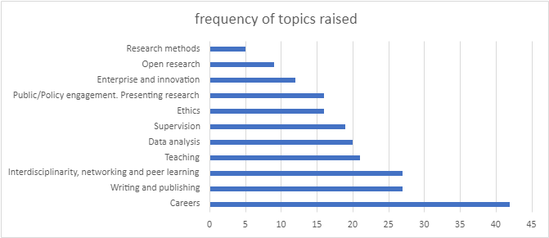

Provision was mapped to the primary RDF domain by asking each stakeholder where their support was most dominant in terms of Domains A (Knowledge and intellectual abilities), B (Personal effectiveness), C (Research governance and organisation) and D (Engagement, influence and impact).

Figure 3. Radar plot of training offer from stakeholders mapped to the major domains of the RDF
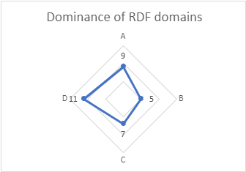

Figure 4. Visualisation of frequency of themes raised and their relationship to the major domains of the RDF
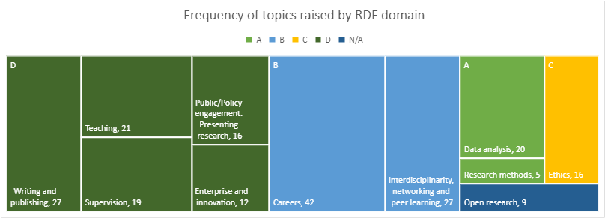

Appendix 2. The full list of stakeholders consulted
Stakeholder | People met with
Careers Service | Peter Evans and Sam Cathro.
GW4 | Sabrina Fairchild.
Open access and research data (Library) | Stephen Gray.
Academic Staff Development and Develop | Claudia Gumm, Simon Swales, Sarah Armstrong.
Research Ethics and Research Culture | Liam McKervey and Marcus Munafo.
Study and research skills (Library) | Simon Gamble, Naomi Nile and James Webley.
Public Engagement and Policy Bristol | Dee Smart, Emily Crick, Nathalie Goodsir.
Enterprise and Innovation | Musti Rampuri, Kimberley Brook and Michelle Barbour.
Research Partnerships | Christine Nileshwar.
Centre for Academic Language Development | Lisa Hanson.
Bristol Institute for Learning and Teaching & Digital Education Office. | Aisling Tierney, Louise Howson, Ros O'Leary, & Roberta Perli.
Faculty PGR Directors - Engineering and Science | Flavia De Luca & Walther Schwarzacher.
Faculty PGR Directors - Arts & SS&L | Damien Mooney & Jutta Weldes.
Faculty PGR Directors - Life Sciences & Health | Harry Mellor & Tom Gaunt.
School PGR directors | Terry McMaster (Physics), Janet Orchard (Education) Susan Parnell (Geography).
PGR admins | Sharen Hockey O'Keefe (BMS), Louise Basey (Arts), Tamsin Berry (Business school).
DTE Director and CDT Managers | Annela Seddon, Rachel Miles, Anona Williams, Sam Southern.
Research Institutes - Cabot and Brigstow | Joanne Norris, Helen Thomas-Hughes & Gail Lambourne.

Appendix 3. Postgraduate research student input
Student input into the Training Review
The PGR reps who attended the meeting were Gina Walter (Arts), Phil Smith (Science) and Shiza Shaikh (Life Sciences). All PGR reps as well as the Student Union Postgraduate Education Officer were invited to the meeting. Following the meeting the notes were shared with both attendees and non attendees to review. No further comments or amendments were received.
Student focus group participants:
11 students attended across 3 small groups.
- All were Full time
- 4 had caring responsibilities
- All were based in Bristol or a commutable distance
Year group | Count |  | Status | Count |  | Faculty | Count |  | Funding | Count
1 | 3 |  | UK | 4 |  | Health | 2 |  | Self-funded | 2
2 | 3 |  | EU | 1 |  | Eng | 2 |  | Partially | 3
3 | 3 |  | Overseas | 6 |  | SS&L | 7 |  | Fully | 6
4+ | 2 |  |  |  |  | Arts | 0
 |  |  |  |  |  | Sci | 0
 |  |  |  |  |  | Life Sci | 0

Appendix 4. Question prompts for the structured discussions to all stakeholders with adaptations for the PGR student representatives.
Question | Adaptation for PGR reps
What do you consider to be training? What is excluded from this definition? | No change
Can you provide a summary of the training PGRs receive from your area? | Can you provide a summary of the training you have received / experienced in your time as a PGR?
How do you see your role in the provision of training for PGRs? Do you think you are doing too much / too little in this area and if so why? | Do you think you have a good understanding of what is available to you as a PGR in regards to training and development? How do you find out opportunities?
Are there stakeholders you collaborate with where there is an area of overlap and how do you manage this? | What sorts of opportunities are available to you through your school? Versus centrally? E.g from the BDC / Careers Service and other support services
What areas of knowledge and skills development do you find PGRs lack the most? | No change
What areas of the training you provide are the most / least popular? | No change
What considerations need to be made to make sure training is inclusive of a diverse range of needs? What issues have you come across? | No change
What domains of the RDF does your training cover? And to what level? (Introductory/in-depth) | Are you aware of the RDF and if so how do you use it? What’s your opinion on it?
Is / does your training /information need to be differentiated for PGRs and academic staff? - If yes why? | Do you think training needs to be differentiated for PGRs and academic staff? why?
What does a successful PGR training offer look like? | No change
Anything else you would like to raise as part of this training review? | No change

http://www.bristol.ac.uk/academic-quality/pg/pgrcode/annex12/
http://www.bristol.ac.uk/doctoral-college/current-research-students/ppd/
https://uob.sharepoint.com/sites/bristol-doctoral-college/SitePages/strategic-plan-for-pgr-2030.aspx
https://uob.sharepoint.com/sites/education-data/SitePages/pres-results.aspx
https://www.vitae.ac.uk/researchers-professional-development/about-the-vitae-researcher-development-framework

